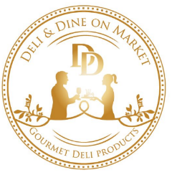
Deli & Dine on Market
Grazing Boxes/ Packages Order Form

NAME:
DATE REQUIRED:
PHONE:
EMAIL:
PICKUP TIME:
DELIVERY ADDRESS:
DELIVERY TIME:

NAME OF BOX: | PRICE: | QUANTITY:
Antipasto Box | $55.00
Cheese Box | $70.00
Fruit Box | $40.00
Baguette Box | $65.00
Sandwich Box | $65.00
Wrap Box | $65.00
Cake/Slice Box | price on request
Morning Tea | $160.00
Lunch | $185.00
Personalised | price on request
Personalised option as follows:

Special Dietary Requirements/ Comments:

PAYMENT OPTIONS: Credit Card / Pay on Pickup (please circle)

Credit Card: _ _ _ _ / _ _ _ _ / _ _ _ _ / _ _ _ _
Exp: _ / _ CVV No: _ _ _
To place your order, email completed form to events.delianddineonmarket@gmail.com or call us on 4228 1335

